Operation Analytics and Investigating Metric Spike
Advanced SQL
Description:
Operational Analytics is a crucial process that involves Analyzing a company's end-to-end operations. This analysis helps identify areas for improvement within the company. As a Data Analyst, you'll work closely with various teams, such as operations, support, and marketing, helping them derive valuable insights from the data they collect.
One of the key aspects of Operational Analytics is investigating metric spikes. This involves understanding and explaining sudden changes in key metrics, such as a dip in daily user engagement or a drop in sales. As a Data Analyst, you'll need to answer these questions daily, making it crucial to understand how to investigate these metric spikes.
In this project, you'll take on the role of a Lead Data Analyst at a company like Microsoft. You'll be provided with various datasets and tables, and your task will be to derive insights from this data to answer questions posed by different departments within the company. Your goal is to use your advanced SQL skills to analyze the data and provide valuable insights that can help improve the company's operations and understand sudden changes in key metrics.
Case Study 1: Job Data Analysis
You will be working with a table named job_data with the following columns:
- job_id: Unique identifier of jobs
- actor_id: Unique identifier of actor
- event: The type of event (decision/skip/transfer).
- language: The Language of the content
- time_spent: Time spent to review the job in seconds.
- org: The Organization of the actor
- ds: The date in the format yyyy/mm/dd (stored as text).
- Data set:
ds | job_id | actor_id | event | language | time_spent | org
11/30/2020 | 21 | 1001 | skip | English | 15 | A
11/30/2020 | 22 | 1006 | transfer | Arabic | 25 | B
11/29/2020 | 23 | 1003 | decision | Persian | 20 | C
11/28/2020 | 23 | 1005 | transfer | Persian | 22 | D
11/28/2020 | 25 | 1002 | decision | Hindi | 11 | B
11/27/2020 | 11 | 1007 | decision | French | 104 | D
11/26/2020 | 23 | 1004 | skip | Persian | 56 | A
11/25/2020 | 20 | 1003 | transfer | Italian | 45 | C

Tasks:
- Jobs Reviewed Over Time:
  - Objective: Calculate the number of jobs reviewed per hour for each day in November 2020.
  - Your Task: Write an SQL query to calculate the number of jobs reviewed per hour for each day in November 2020.
Code:
SELECT ds,sum(time_spent) AS Total_time_spent,
COUNT(job_id) as Number_of_total_jobs,
ROUND((SUM(time_spent) / COUNT(job_id)), 1) AS Time_taken_for_each_job_in_secs,
CASE
WHEN SUM(time_spent) > 0 THEN (SUM(time_spent)/3600 )
ELSE
0
END AS Reviews_in_an_hour_on_each_day_of_November
FROM job_data
GROUP BY ds
ORDER BY Total_time_spent;
Result:
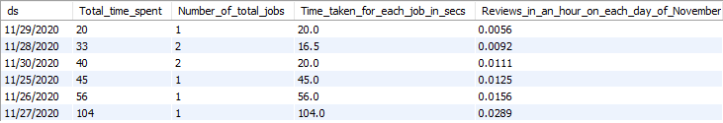
- Throughput Analysis:
  - Objective: Calculate the 7-day rolling average of throughput (number of events per second).
  - Your Task: Write an SQL query to calculate the 7-day rolling average of throughput. Additionally, explain whether you prefer using the daily metric or the 7-day rolling average for throughput, and why.
Code:
select round(count(event)/sum(time_spent), 2) as Throughput_weekly_basis
from job_data;
select ds as Date, round(count(event)/sum(time_spent), 2) as Throughput_daily_basis
from job_data
group by ds
order by ds;
Result:
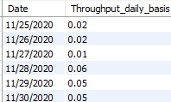
- Language Share Analysis:
  - Objective: Calculate the percentage share of each language in the last 30 days.
  - Your Task: Write an SQL query to calculate the percentage share of each language over the last 30 days.
Code:
select language, round(100*count(*)/total,2) as Percentage, sub.total from job_data
cross join(
select count(*) as total from job_data) as sub
group by language, sub.total;
Result:
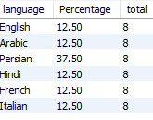
- Duplicate Rows Detection:
  - Objective: Identify duplicate rows in the data.
  - Your Task: Write an SQL query to display duplicate rows from the job_data table
Code:
with cte as(
select actor_id,ds,job_id,event,language,time_spent,org, row_number()
over(partition by actor_id,ds,job_id,event,language,time_spent,org
order by actor_id) as RN
from job_data)
select * from cte where RN >1;
-- Approch two:-
select actor_id, count(*) as Duplicates from job_data
group by actor_id having count(*)>1;
Result:
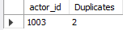
Case Study 2: Investigating Metric Spike
You will be working with three tables:
- users: Contains one row per user, with descriptive information about that user’s account.
- events: Contains one row per event, where an event is an action that a user has taken (e.g., login, messaging, search).
- Email events: Contains events specific to the sending of emails.
Tasks:
- Weekly User Engagement:
  - Objective: Measure the activeness of users on a weekly basis.
  - Your Task: Write an SQL query to calculate the weekly user engagement.
Code:-
SELECT * FROM email_events;
SELECT
WEEK(STR_TO_DATE(occurred_at, '%d-%m-%Y %H:%i')) AS Weeks,
COUNT(DISTINCT user_id) AS Engaged_user
FROM email_events
WHERE action = "sent_weekly_digest"
GROUP BY Weeks
ORDER BY Weeks;

-- Note:
-- EXTRACT(WEEK FROM STR_TO_DATE(occurred_at, '%d-%m-%Y %H:%i')) AS Weeks.alter
Above code can also be used to get the same result. EXTRACT(WEEK FROM ...) is a general-purpose function that can extract various date parts (e.g., year, month, day) from a date. By specifying WEEK, you instruct it to extract the week number from the date.
But in our question set, they only asked for the weeks, that's why we use WEEK(), which is specifically designed to extract only the week number from a date.
Result:-
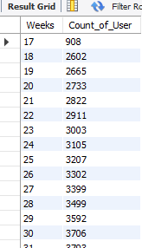
- User Growth Analysis:
  - Objective: Analyze the growth of users over time for a product.
  - Your Task: Write an SQL query to calculate the user growth for the product.
Code:
SELECT
YEAR(STR_TO_DATE(created_at, '%d-%m-%Y %H:%i')) AS Year,
MONTH(STR_TO_DATE(created_at, '%d-%m-%Y %H:%i')) AS Month,
WEEK(STR_TO_DATE(created_at, '%d-%m-%Y %H:%i')) AS Week,
COUNT(DISTINCT user_id) AS New_Users,
SUM(COUNT(DISTINCT user_id)) OVER
(ORDER BY Year(STR_TO_DATE(created_at, '%d-%m-%Y %H:%i'))
ROWS BETWEEN 2 PRECEDING AND CURRENT ROW) AS Sum_of_newly_joined_users
FROM
users
GROUP BY
Year,Month,Week
ORDER BY
Year;
Result:
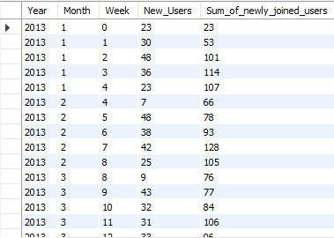
Note:
In some places, the number of newly joined users has decreased, From the above table, we can see that the number of freshly joined users has decreased from 101 to 66 between weeks 2 and 3, from 107 to 76 between weeks 3 and 4, from 128 to 105 between weeks 3 and 4, from 106 to 84 between weeks 3 and 4, and from 106 to 84 between weeks 3 and 4. In all other cases, the number of newly joined users has increased from the previous week. Now companies can find out the specific area where they lose their customers, and work accordingly.
- Weekly Retention Analysis:
  - Objective: Analyze the retention of users on a weekly basis after signing up for a product.
  - Your Task: Write an SQL query to calculate the weekly retention of users based on their sign-up cohort.
Code:
SELECT
WEEK(STR_TO_DATE(occurred_at, '%d-%m-%Y %H:%i')) AS Week,
COUNT(DISTINCT user_id) AS Total_users
FROM events
WHERE event_type = 'signup_flow' AND event_name = 'complete_signup'
GROUP BY Week
ORDER BY Week;
Result:
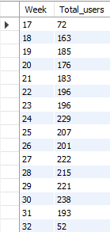
Note:
From Week 17 to Week 32, we observe fluctuations in user retention, with a steady increase in total users, peaking around Week 30, followed by a noticeable decline through Week 32. This pattern indicates that user engagement may drop off after Week 30. To improve retention, we can analyze factors contributing to these drop-off points and implement targeted strategies to sustain engagement. By identifying specific points where users disengage, we can enhance the user experience and develop effective retention tactics to maintain a steady user base.
- Weekly Engagement Per Device:
  - Objective: Measure the activeness of users on a weekly basis per device.
  - Your Task: Write an SQL query to calculate the weekly engagement per device.
Code:
SELECT
device,
WEEK(STR_TO_DATE(occurred_at, '%d-%m-%Y %H:%i')) AS Week,
COUNT(DISTINCT user_id) AS Number_of_users
FROM events
WHERE event_type = 'engagement'
GROUP BY device, Week
ORDER BY Week;
Result:
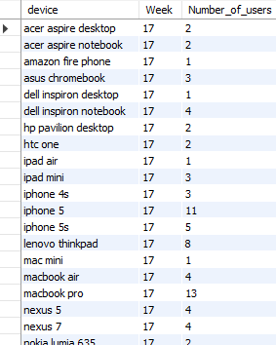
Note:
"We are tracking weekly user activity by device to assess engagement levels. The data shows that user engagement varies across different devices, with some devices consistently having higher engagement than others. To improve engagement, we can analyze factors affecting these variations, focusing on device compatibility and optimizing the user experience. Additionally, monitoring trends for devices with lower engagement will help us identify specific challenges, allowing us to develop targeted strategies to enhance engagement on these devices."
- Email Engagement Analysis:
  - Objective: Analyze how users are engaging with the email service.
  - Your Task: Write an SQL query to calculate the email engagement metrics.
Code:
SELECT
DATE_FORMAT(STR_TO_DATE(occurred_at, '%d-%m-%Y %H:%i'), '%Y-%m') AS Month,
COUNT(CASE WHEN action = 'sent_weekly_digest' THEN 1 END) AS Emails_Sent,
COUNT(DISTINCT CASE WHEN action = 'email_open' THEN user_id END) AS Unique_Openers,
COUNT(CASE WHEN action = 'email_clickthrough' THEN 1 END) AS Total_Clicks,
COUNT(DISTINCT CASE WHEN action = 'email_clickthrough' THEN user_id END) AS Unique_Clickers,
CASE
WHEN COUNT(DISTINCT CASE WHEN action = 'email_open' THEN user_id END) > 0
THEN ROUND(COUNT(DISTINCT CASE WHEN action = 'email_clickthrough' THEN user_id END) /
COUNT(DISTINCT CASE WHEN action = 'email_open' THEN user_id END) * 100, 2)
ELSE 0
END AS Click_Through_Rate
FROM
email_events
GROUP BY
Month
ORDER BY
Month;
Result:
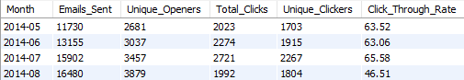
Note:
The engagement data for the weekly digest emails between May and August 2014 shows positive trends with some fluctuations:
- Emails Sent: Monthly email volume increased from 11,730 in May to 16,480 in August, suggesting a growing user base or enhanced outreach.
- Unique Openers: Unique openers also rose, from 2,681 in May to 3,879 in August, reflecting increased engagement and interest among users.
- Clicks and Clickers: Both total clicks and unique clickers peaked in July but dropped in August, with clicks decreasing from 2,721 to 1,992, and unique clickers from 2,267 to 1,804.
- Click-Through Rate (CTR): The CTR remained strong, above 60% in most months, peaking at 65.58% in July. However, August showed a notable decrease to 46.51%, suggesting possible user fatigue or content relevance issues.

Please note that for each task, you should also provide insights and interpretations of the results obtained from your queries.
How to do this Project?
- Create the Database and Tables: Start by creating a database for the project and then create the necessary tables using the provided table structures and links. You need to import the csv file into MySQL Workbench.
- Perform Analysis: Utilize SQL to perform the analysis and answer the questions mentioned in the case studies. Ensure that you understand the table structures and the meaning of various columns such as event types and what to consider for reviewing.
- Submit a Report: Prepare a report (PDF/PPT) to present your findings to the leadership team. The report should include the following details:
Project Description
Provide a brief overview of the project, explaining its purpose and how you plan to handle the analysis.
Approach
Describe your approach towards the project and explain how you executed the analysis.
Tech-Stack Used
Mention the software and versions used for the project, such as MySQL Workbench, and explain their purpose in the analysis.
Insights
Summarize the insights and knowledge you gained during the project. Highlight key observations and inferences you made from the data, keeping them concise and to the point.
Result
Discuss what you have achieved through the project and explain how it has contributed to your understanding and decision-making.
Drive Link
Save your report as a PDF file and upload it to your Google Drive. Include the shareable link (with public visibility) in your report. Check the detailed steps below for submission.
Note: Make sure you mention the SQL Queries along with the outputs in the report. You can take snapshots of the SQL Queries and the outputs. It is advised to do the project in MySQL Workbench.
How to Submit your Project:
Step 1 Do your project in PPT/PDF. It’s your choice. For PDF, write your project in Ms Word, then save the file in PDF format. You will find the option in the ‘Save As’ Box.
Step 2 Now, upload the file i.e., PPT/PDF on your google drive. It would be wise to create a Single Folder and Name it “Trainity Assignments”. Inside that folder, create another Folder name “Project Name”. Upload your assignment there.
Step 3 Right Click on the File, and select ‘Get Link’ under ‘Share’. A Dialog Box will Pop up. Inside the Box, Under General Access, Change ‘Restricted’ to ‘Anyone with the Link’. No need to change anything else.
Step 4 Click on ‘Copy Link’.
Step 5 Now paste the link in the Drive Link box when submitting the project.
Judgement Criteria:
SQL Understanding
The SQL queries used should provide correct outputs and be easily understandable. Ensure that the queries are accurate, efficient, and well-structured.
Case study completion
All the questions presented in the case studies must be answered completely with accurate responses. Address each question thoroughly, demonstrating your understanding of the analysis required.
Insights
Use your own imagination and creativity to answer the case study questions, providing insightful and meaningful observations and recommendations. Think beyond the obvious and showcase your ability to derive valuable insights from the data.
Plagiarism
The project should be your own original work and should not be copied from the internet or any other source. Ensure that the analysis, interpretations, and visualizations are your own, demonstrating your skills as a data analyst.
By following these guidelines and demonstrating your SQL understanding, completing the case studies, providing insightful observations, and avoiding plagiarism, you will showcase your expertise and deliver a comprehensive and original SQL project.

